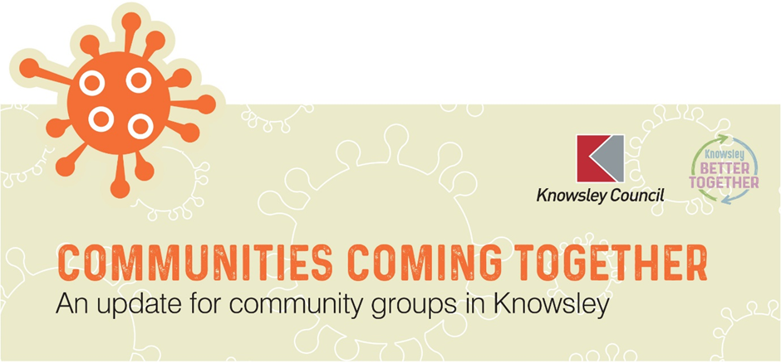
Issue 20
Welcome to the latest newsletter for community groups.
As we emerge from lockdown we continue to remind residents of the rules they still need to follow to ensure we can successfully move through the Government’s roadmap. To support this we’ve produced a number of social media images which we’ll attach to this newsletter – and hope you will share through your networks. Many thanks for your continued support.
From your Communities Team
Kirkby: Jacqui Meadows, 07811 849121, Jacqui.Meadows@knowsley.gov.uk
Huyton: Pauline Coulton, 07919 211402, Pauline.coulton@knowsley.gov.uk; Tommy Dunn, 07717 301300, tommy.dunn@knowsley.gov.uk;
PWCKV & Halewood: Jeff Sayers, 078100 53826, jeff.sayers@knowsley.gov.uk; John Mashford, 07766367878, john.mashford@knowsley.gov.uk

This week on Knowsley News online
Aged 45 and over? Book your COVID vaccination appointment - Knowsley News
Moderna vaccine rolls out on Merseyside - Knowsley News
Knowsley Working Well Covid-19 Workplace Grant goes live - Knowsley News
Looking after your mental health as lockdown restrictions ease - Knowsley News

Social media posts
Vaccination open to 45+
Facebook and Twitter
The COVID-19 vaccination programme in Knowsley is now open to those aged 45+. Appointments can be made online or by calling 119. Find out more https://www.knowsleynews.co.uk/covid-19-vaccination-appointments-now-open-to-those-aged-45/
QR Code
Facebook
Knowsley businesses who are required to take part in NHS Track and Trace are being reminded that it is a legal requirement to display their individual NHS Track and Trace QR code poster. Posters can be generated online. https://www.knowsleynews.co.uk/not-displaying-your-track-and-trace-qr-code-its-a-legal-requirement-that-you-do/
Twitter
Knowsley businesses who log customer details are being reminded that it is a legal requirement to display the NHS Track and Trace QR code poster. Find out more https://www.knowsleynews.co.uk/not-displaying-your-track-and-trace-qr-code-its-a-legal-requirement-that-you-do/
Wear a face covering
Facebook
Knowsley residents are being urged to wear a face covering where required, unless exempt. With social contact increasing as lockdown restrictions ease, it is vital everyone plays their part in reducing the spread of the virus where possible. https://www.knowsleynews.co.uk/slow-the-spread-and-wear-a-face-covering/
Twitter
Knowsley residents are being urged to wear a face covering where required, unless exempt to help reduce the spread of the virus where possible. https://www.knowsleynews.co.uk/slow-the-spread-and-wear-a-face-covering/
Play your part in keeping hospitality open
Facebook and Twitter
With outdoor hospitality now reopen, Knowsley residents are being asked to play their role in making the return of the borough’s pubs, bars and restaurants safe and successful. https://www.knowsleynews.co.uk/reopening-hospitality-what-to-you-expect-and-how-to-play-your-part/
Download the Track and Trace App
Facebook
The NHS Track and Trace app is the easiest way to check into a venue. By sharing your details, you can be quickly contacted if you need to self-isolate and protect those around you. That is why Knowsley Council is urging all residents to download the app where possible. https://www.knowsleynews.co.uk/protect-your-loved-ones-download-the-nhs-track-and-trace-app/
Twitter
The NHS Track and Trace app is the easiest way to check into a venue. By sharing your details, you can be quickly contacted if you need to self-isolate and protect those around you. https://www.knowsleynews.co.uk/protect-your-loved-ones-download-the-nhs-track-and-trace-app/

Coronavirus cases in Knowsley by ward
https://www.knowsley.gov.uk/residents/coronavirus-cases

Contact us
Community groups across the borough are invited to raise questions using this inbox. The Neighbourhood team will get back to you. Covid19CommunityResponse@knowsley.gov.uk
For general queries and advice on managing a potential outbreak please contact: 0151 443 4712 or *email COVID19.SPOC@knowsley.gov.uk
This line is available Monday to Friday 9am-5pm. This is an answerphone, but the message left will be passed on to an officer within one hour. For out of hours support after 5pm, at weekends or on a Bank Holiday, please contact: Public Health England North West Health Protection Team on 0151 434 4819
Please Note* The SPOC email contact is not for use by the general public. It is primarily for workplaces, community centres and community groups across the borough.

