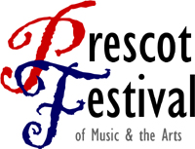
a

Mayor of Prescot’s
CHARITY CHRISTMAS CONCERT

Thursday 12th December, 7.00pm-8.15pm
Prescot Parish Church, Church Street, Prescot, L34 3LA

Brassworks Quartet
Prescot Parish Church Choir
St Mary & St Paul’s Primary School Choir
Bluebell Park School Makaton Signing Choir
Evelyn Community Primary School & Staff Choirs

Christmas favourites, sing-a-long carols
& festive refreshments!

Tickets £5 on the door (accompanied under 16s free)
All proceeds to the Mayor of Prescot’s Charities:
Local Community Volunteer Groups

www.prescotfestival.co.uk

16th Annual Prescot Festival – Friday 19th to Sunday 28th June 2020

