

Cockpit House,

Prescot

May 2017

**Dear Friends of Shakespeare North,**

With the arrival of spring it seems a particularly appropriate time to reflect on the exciting developments which are transforming our plan to build the Shakespeare North Playhouse and education hub in Prescot into a wonderful reality.

This time last year, in April 2016, we heard the marvellous news that planning permission had been awarded by Knowsley Council, together with a generous gift of land, and a pledge of financial support at both local and national government level.

As I am sure you can imagine, the last few months have been an absolute whirl of activity! Here are a few of the most significant milestones and achievements which we wanted to share with you:

**Assembling the construction team:** in November, Helm architecture was appointed to design and oversee the completion of our unique theatre - together with Austin Smith: Lord LLB as the supporting architects. Key members of the design team have now been appointed, too – AECOM Ltd will supply mechanical, electrical and fire engineering services, together with expertise in cost consultancy and acoustics. AECOM are, of course, renowned in Liverpool for the wonderful transformation of Liverpool’s landmark Central Library. Mott McDonald will provide structural engineers whilst Ove Arup & Partners have been awarded the role of theatre consultant.

Initial interviews are currently taking place for the building team and, in compliance with planning conditions, an archaeologist is being appointed to excavate the site prior to building taking place. An initial survey has already revealed historical artefacts dating from as early as the fourteenth century, as archaeologist Dr Robert Philpott explains in this clip: <http://knowsleynews.co.uk/artefacts-found-prescot/>.

With these appointments in place, we hope that construction will begin in January 2018, with the theatre opening in 2020. Just imagine sitting in this stunning performative space!

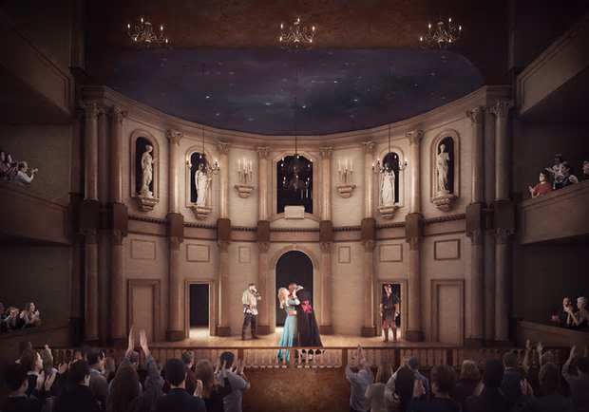

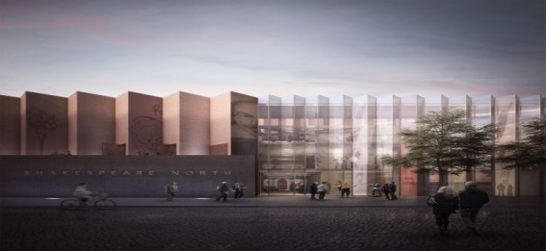**Shakespeare North Architectural Group:** in preparation for building work, the Shakespeare North Architectural Group has been busy hosting a series of workshops to consider the central question of how this incredible theatre will best meet the diverse needs of actors, directors, students and the local community.

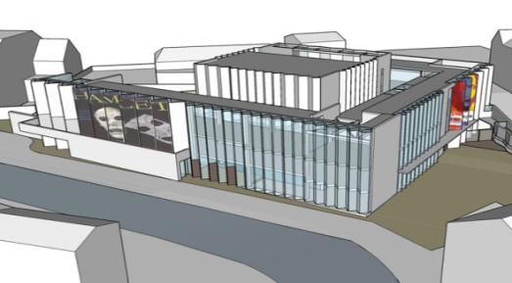The first event was held at the University of Warwick and explored Inigo Jones’ original designs for the Cockpit-in-Court theatre in Whitehall. The second workshop took place at Liverpool John Moores University on December 16th 2016 and considered the more practical demands of transforming Inigo Jones’ seventeenth-century designs into a living twenty-first century theatre.

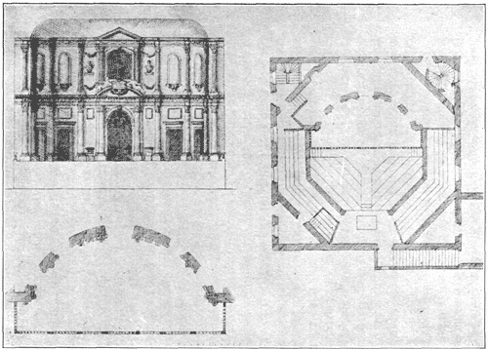The third event was hosted in January 2017 by Professor Sir Jonathan Bates at Worcester College, University of Oxford. This offered the opportunity to examine the original designs by Inigo Jones and John Webb and consider questions such as lighting and seating – although, luckily, we don’t have to worry where the King would sit as they would have done in the seventeenth century! As the adjacent theatre designs illuminate these fascinating questions are crucial to the success of the project.

**International Shakespeare Symposium at Knowsley Hall:** on 19th October 2016, leading scholars of Elizabethan and Jacobean theatre gathered from across the globe to explore the deep involvement of the Earls of Derby and other members of the Stanley family in the world of Shakespearean theatre, especially in the North West. This landmark event, celebrating the four hundredth anniversary of Shakespeare’s death, was hosted by the Earl and Countess of Derby, and included the recreation of a masque, last performed at Knowsley Hall in 1641.

The symposium was expertly organised by Professor Elspeth Graham (Liverpool John Moores University) and Dr Stephen Lloyd, (Curator of Knowsley Hall) with eminent speakers including Professor Lawrence Manly (Yale University), Professor Sally Beth-MacLean (Toronto University) and Professor David George (Urbana University, Ohio). We were delighted that so many people from the Knowsley area attended the event. If you would like to read the full programme, please click on the link below. <http://knowsleyhallvenue.co.uk/wp/wp-content/uploads/2016/09/26th-August-2016-UpdatePress-Quality-2016-Shakespeare-Symposium-A5-3mmBleed.pdf>

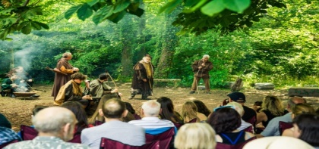**Shakespeare North Community Engagement Group:** meanwhile,in July 2016, a reception was held, here at Cockpit House, to celebrate with, and thank, the local community for helping us to achieve our Shakespeare North vision. A champagne reception was followed by the opportunity to see a wonderful production of *As You Like It* performed with great aplomb by MATE production company. The magical woodland setting of Prescot Church ensured a very memorable evening. Just click on the link to see the good people of Prescot bringing Jacques’ ‘All the world’s a stage’ monologue to life: <http://mateproductions.co.uk/as-you-like-it/>.

This summer MATE will be performing *The Tempest* and touring in association with RSC Open Stages. So don’t forget to book your tickets for this or the annual Elizabethan Fayre at Prescot which will be taking place on June 3rd 2017.

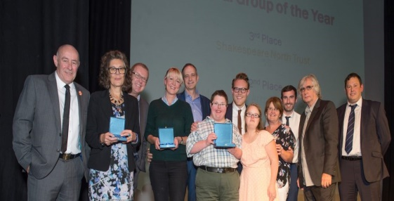

Last Autumn, the Shakespeare North Trust and MATE productions both won awards for Knowsley Cultural Groups of the Year. Shakespeare North was particularly commended in the 400th anniversary year of the death of Shakespeare for ‘tirelessly working’ to make the Shakespeare North vision an incredible reality.

**Shakespeare North Education Projects:** using the different stages of life highlighted by Jaques’ in his celebrated ‘Seven Ages of Man’ speech, education is central to Shakespeare North, especially our partnership with the local community and schools. Already, St Margaret Mary’s Junior School in Huyton, has had the inspired idea of planning to build a replica wooden Globe in the playground, to be used for pupil performance and storytelling. Likewise, All Saints Catholic High School and Halewood Academy will be special partner schools. Whilst within the theatre itself, an MA is being developed in conjunction with Liverpool John Moores University which will focus on Shakespearean stagecraft.

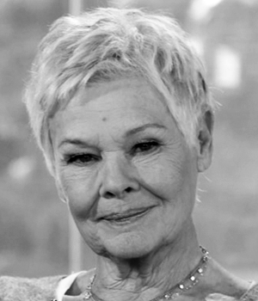**Shakespeare North Patron update:** in the New Year, we were delighted to read Dame Judy Dench’s ‘Letter to Liverpool’ where she spoke of her love for Liverpool, the home of her actor husband, Michael Williams, and pledged her support for the Shakespeare North Project, writing: ‘great Shakespearean performances can change lives and I want to help offer hope, vision and an enhanced educational experience to the children of Knowsley and Liverpool’. Do read the full letter here: <http://knowsleynews.co.uk/dame-judi-dench-shakespeare-north/>.

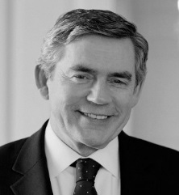Meanwhile, in February, former Prime Minister Gordon Brown agreed to become a patron for Shakespeare North. A staunch supporter of the project since 2008, he, too, stressed the transformational element of the project, declaring: ‘you will change the lives of thousands of young people by giving them a chance to develop their talents’.

Thank you for taking the time to reflect on the astonishing journey of Shakespeare North this year. These events are indeed, as Prospero reminds us, ‘such stuff / As dreams are made on’. None of this, however, would be possible without your enduring support.

With kind regards and enormous thanks,

The Shakespeare North Trust

